DOCUMENT HISTORY AND INFORMATION
WRITE BY: 21130317_LamTrachDong
History of Amendments:
Date | Version | Modified Section | Summary of Change | Author
12/10/24 | 0.1 | ALL | Create | LT Đông
18/10/24 | 1.0 | ALL | Complete final version | LT Đông

Introduction
The document provides detailed requirements for the search functionality on a website, aiming to assist the development team and stakeholders in understanding and implementing the feature effectively.

Purpose
The purpose of this document is to outline the necessary requirements for the search feature that allows users to input keywords and receive a list of relevant results from the website's database.

Scope
The search functionality enables users to enter keywords and retrieve a list of related results from the website's database.

Definitions, Acronyms and Abbreviations
<TBD>
UC | Name | Description
UC001 | Search products | Enter keywords and retrieve results

Overview

Use case diagram
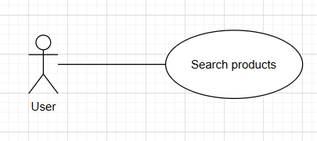

Initial Step-By-Step Description
Before this use case can be initiated, the User has already accessed Website.

1. The User enter keywords to search.

2. The system displays the results for the User to select.

3. User select the desired product to view details.

Functionality Requirements

Search Interface

Search Bar


The search bar allows users to enter keywords, product names, and brands to search for, then returns the desired product results after pressing Enter.
If the entered keyword contains special characters, the system will remove them and only search for non-special characters.
The keyword input can be accented or unaccented.

Search History
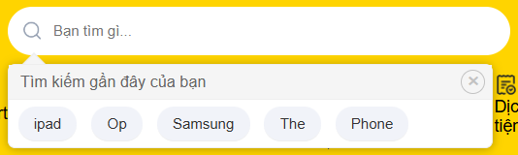

The system will automatically save the user's search keywords.
When focusing on the search bar, the system will display a list of keywords you have recently searched for, so you can reuse them.
Click the "X" button in the upper right corner of the box to delete all recently searched keywords from the search history.

Automatic Suggestions
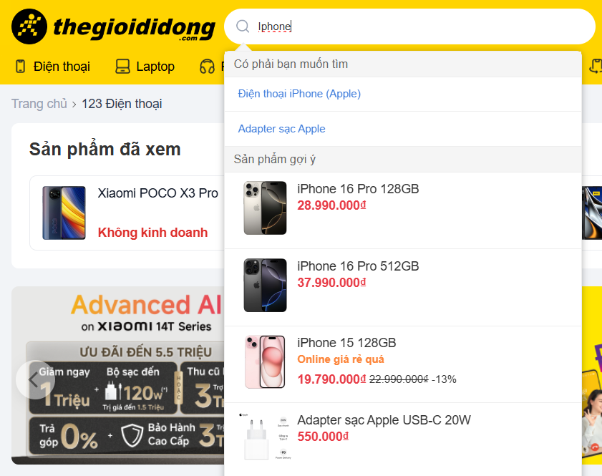

Completion Suggestions
When the user begins to enter a keyword, the system will suggest completion of the word being entered, based on previously searched keywords or from the product list.

Suggested Related Products
The system will provide suggestions for products related to the word the user is typing.

Results Interface

Search Results
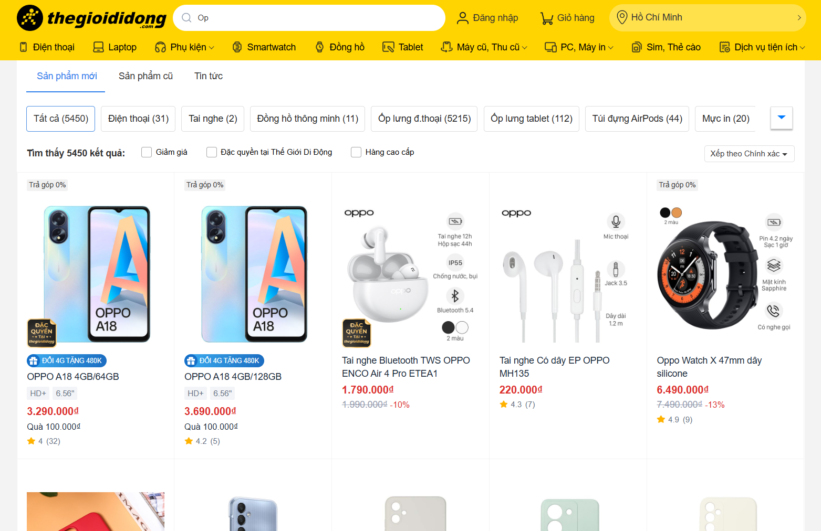

The search results will be:
A list of products related to the keyword.
Count the number of results found.
Filtering related features.
Sort options.

Results Not Found
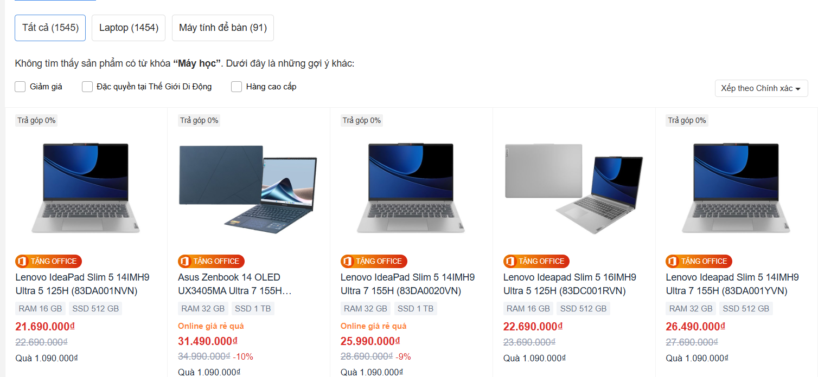

When results similar to the keyword cannot be found, announcement out “Không tìm thấy sản phẩm có từ khóa {keyword}.”.
At the same time, the system will provide approximate results, displaying products or information similar to the search keyword, helping users find other information more easily.
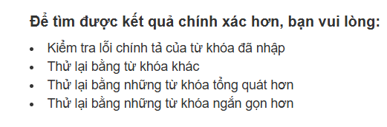
When results similar to the keyword cannot be found and the system cannot provide approximate result, then it displays as shown in the image above.

